**Color detection and grabbing**

**Objective:**

In this project the Arduino will detect the color of the object (Red, Green, Blue, Black, White) using the handmade color sensor, and will pick up and relocate the object of a certain color, 90 degrees to its arm’s left.

**Requirements:**

1x Arduino Uno

4x MG90S Servo motor,

1x LDR,

1x RGB LED,

1x 330Ω Resistor,

1x 1kΩ Resistor,

MeArm parts (designs available at <https://mearm.com> ),

And other equipment including some wire, tape, …

**How to use:**

After the code being uploaded to Arduino, you can open serial monitor for instructions. Right after upload, you should hold a completely white surface to the sensor and after all the colors of the LED flashed, hold a completely black surface to it for a few seconds. Then the device is ready to use. It will grab and relocate any object with the color specified in the code (red) to 90 degrees to the left of itself.

**Setup:**

The wires should be connected as shown in the images.

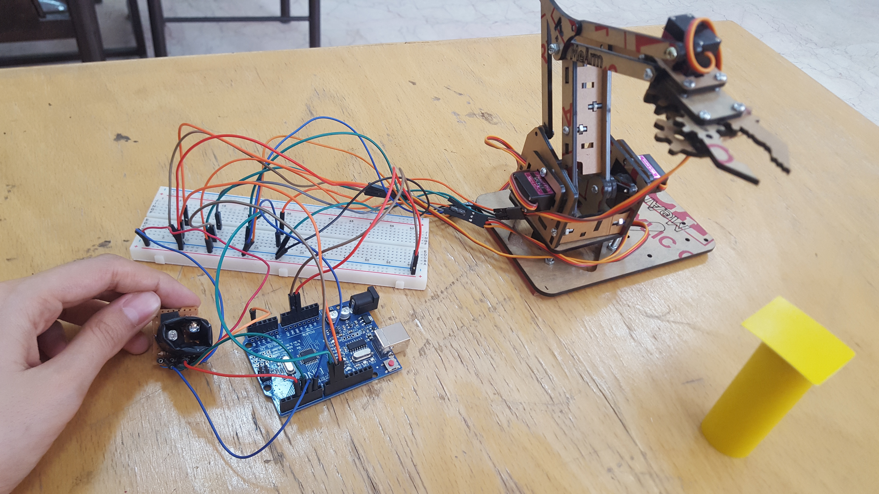

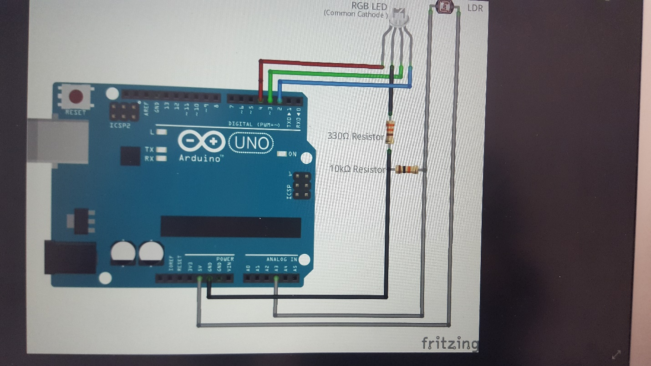

**Code:**

#include<Servo.h>

//Set Servoes:

Servo middle, left, right, claw ;

int middleP=90, leftP=90, rightP=90, clawP=110;

//Set Sensor:

int ledArray[] = {5, 4, 3};

boolean balanceSet = false;

int red = 0;

int green = 0;

int blue = 0;

float colourArray[] = {0, 0, 0};

float whiteArray[] = {0, 0, 0};

float blackArray[] = {0, 0, 0};

int avgRead;

int color = 0; // white, red, green, blue, ..., black=10

//------------------------------------------------------

void setup() {

Serial.begin(9600);

//Set Sensor:

pinMode(3, OUTPUT);

pinMode(4, OUTPUT);

pinMode(5, OUTPUT);

pinMode(A4, INPUT);

//Set Servo:

middle.attach(11);

left.attach(10);

right.attach(9);

claw.attach(6);

position(middleP,leftP,rightP,clawP);

}

//--------------------------------------------------------

void loop() {

checkBalance();

checkColour();

printColour();

if (color = 1){

//pick up if red

getTarget();

}

delay(2000);

}

//-------------------------------------------------------

//------------------------Arm----------------------------

void getTarget(){

position(90,90,90,110); // front position

delay(500);

position(90,90,70,110); //get back a little

delay(500);

position(90,65,70,110); // go down

delay(500);

position(90,60,90,110); // go forward a little

delay(500);

position(90,60,90,170); // grip

delay(500);

position(90,100,70,170); // get up

delay(500);

position(180,100,70,170); // go left (up)

delay(500);

position(180,60,90,170); // get back

delay(500);

position(180,65,70,110); // let go

delay(500);

position(180,100,70,110);// get up (left)

}

//------------------------------------------------------------

void position (int m, int l, int r, int c){ // 0-200 degrees

middleP=m;

leftP=l;

rightP=r;

clawP=c;

middle.write(m);

left.write(l);

right.write(r);

claw.write(c);

}

//--------------------------------------------------------

//------------------------Sensor--------------------------

void checkBalance(){

if (balanceSet == false)

{

setBalance();

}

}

//--------------------------------------------------------

void setBalance(){

digitalWrite(ledArray[3], HIGH);

digitalWrite(ledArray[4], HIGH);

digitalWrite(ledArray[5], HIGH);

//set white balance

delay(100);

setEmpty();

setWhite();

setBlack();

balanceSet = true;

Serial.println("Now you can expose the sensor to any color");

delay(5000);

}

//--------------------------------------------------------

void setEmpty(){

Serial.println("Please Wait");

for (int i = 0; i <= 2; i++)

{

digitalWrite(ledArray[i], LOW);

delay(100);

digitalWrite(ledArray[i], HIGH);

delay(100);

}

}

//--------------------------------------------------------

void setWhite(){

Serial.println("Please expose the sensor to White");

delay(5000);

Serial.println("Seting White");

for (int i = 0; i <= 2; i++)

{

digitalWrite(ledArray[i], LOW);

delay(100);

getReading(5);

whiteArray[i] = avgRead;

digitalWrite(ledArray[i], HIGH);

delay(100);

}

}

//--------------------------------------------------------

void setBlack(){

Serial.println("Please expose the sensor to Black");

delay(5000);

Serial.println("Seting Black");

for (int i = 0; i <= 2; i++)

{

digitalWrite(ledArray[i], LOW);

delay(100);

getReading(5);

blackArray[i] = avgRead;

digitalWrite(ledArray[i], HIGH);

delay(100);

}

}

//--------------------------------------------------------

void checkColour(){

for (int i = 0; i <= 2; i++)

{

digitalWrite(ledArray[i], LOW);

delay(100);

getReading(5);

// colourArray[i] = avgRead;

// float greyDiff = whiteArray[i] - blackArray[i];

// colourArray[i] = (colourArray[i] - blackArray[i]) / (greyDiff)*255; //the reading returned minus the lowest value divided by the possible range multiplied by 255 will give us a value roughly between 0-255 representing the value for the current reflectivity(for the colour it is exposed to) of what is being scanned

colourArray[i] = map(avgRead, blackArray[i], whiteArray[i], 0, 255);

digitalWrite(ledArray[i], HIGH);

delay(100);

}

}

//--------------------------------------------------------

void getReading(int times){

int reading;

int tally = 0;

for (int i = 0; i < times; i++)

{

reading = analogRead(A4);

tally = reading + tally;

delay(10);

}

avgRead = (tally) / times;

}

//--------------------------------------------------------

void printColour(){

Serial.print("R = ");

Serial.print(int(colourArray[0]));

Serial.print("\tG = ");

Serial.print(int(colourArray[1]));

Serial.print("\tB = ");

Serial.print(int(colourArray[2]));

Serial.println("\tColor:\t");

if((colourArray[0]>230)&&(colourArray[1]>230)&&(colourArray[2]>230)){

Serial.println("White");

color = 0;

}else

if((colourArray[0]<30)&&(colourArray[1]<30)&&(colourArray[2]<30)){

Serial.println("Black");

color = 10;

}else

if((colourArray[2]>colourArray[0])&&(colourArray[2]>colourArray[1])&&(colourArray[2]>130)&&(colourArray[0]<40)){

Serial.println("Blue");

color = 3;

}else

if((colourArray[1]>colourArray[0])&&(colourArray[1]>colourArray[2])&&(colourArray[1]>130)&&(colourArray[0]<40)){

Serial.println("Green");

color = 2;

}else

if((colourArray[0]>colourArray[1])&&(colourArray[0]>colourArray[2])){

Serial.println("Red");

color = 1;

}else

Serial.println("-");

}

//--------------------------------------------------------

//--------------------------------------------------------